MockPractice Assessment – 1

1) UserStory 1
Event Management Homepage (HTML, CSS, Bootstrap)
Scenario
Design a responsive homepage for an Event Management company showcasing upcoming events, event highlights, and a registration form. The page should use semantic HTML5 elements and Bootstrap components for layout and styling.

Code Snippets
<!DOCTYPE html>
<html lang="en">
<head>
<meta charset="UTF-8" />
<title>Event Horizon</title>
<meta name="viewport" content="width=device-width, initial-scale=1" />

<link
href="https://cdn.jsdelivr.net/npm/bootstrap@5.3.2/dist/css/bootstrap.min.css"
rel="stylesheet"
/>
<link rel="stylesheet" href="style.css" />
</head>

<body>
<header class="bg-dark text-white p-3">
<nav class="container d-flex justify-content-between">
<h3>Event Horizon</h3>
<ul class="nav">
<li class="nav-item"><a class="nav-link text-white" href="#events">Events</a></li>
<li class="nav-item"><a class="nav-link text-white" href="#register">Register</a></li>
</ul>
</nav>
</header>

<main class="container my-4">
<section id="events" class="mb-5">
<h2 class="mb-3">Upcoming Events</h2>
<div class="row g-4">
<div class="col-md-4">
<div class="card">
<img src="https://picsum.photos/300/200?1" class="card-img-top" />
<div class="card-body">
<h5 class="card-title">Tech Conference</h5>
<p class="card-text">Latest trends in software development.</p>
<button class="btn btn-primary" data-bs-toggle="modal" data-bs-target="#infoModal">
View Details
</button>
</div>
</div>
</div>

<div class="col-md-4">
<div class="card">
<img src="https://picsum.photos/300/200?2" class="card-img-top" />
<div class="card-body">
<h5 class="card-title">Music Fest</h5>
<p class="card-text">Experience live performances.</p>
<button class="btn btn-primary" data-bs-toggle="modal" data-bs-target="#infoModal">
View Details
</button>
</div>
</div>
</div>

<div class="col-md-4">
<div class="card">
<img src="https://picsum.photos/300/200?3" class="card-img-top" />
<div class="card-body">
<h5 class="card-title">Startup Meetup</h5>
<p class="card-text">Network with entrepreneurs.</p>
<button class="btn btn-primary" data-bs-toggle="modal" data-bs-target="#infoModal">
View Details
</button>
</div>
</div>
</div>
</div>
</section>

<section id="register">
<h2 class="mb-3">Event Registration</h2>
<form class="row g-3 needs-validation" novalidate>
<div class="col-md-6">
<label class="form-label">Full Name</label>
<input type="text" class="form-control" required />
</div>

<div class="col-md-6">
<label class="form-label">Email</label>
<input type="email" class="form-control" required />
</div>

<div class="col-12">
<button class="btn btn-success">Register</button>
</div>
</form>
</section>
</main>

<footer class="bg-dark text-white text-center p-3">
© 2026 Event Horizon
</footer>

<!-- Modal -->
<div class="modal fade" id="infoModal">
<div class="modal-dialog">
<div class="modal-content">
<div class="modal-header">
<h5 class="modal-title">Event Details</h5>
<button class="btn-close" data-bs-dismiss="modal"></button>
</div>
<div class="modal-body">
Event details will be announced soon.
</div>
</div>
</div>
</div>

<script src="https://cdn.jsdelivr.net/npm/bootstrap@5.3.2/dist/js/bootstrap.bundle.min.js"></script>
</body>
</html>

Style.css
body {
font-family: Arial, sans-serif;
}

.card img {
height: 180px;
object-fit: cover;
}

Output Screenshots:
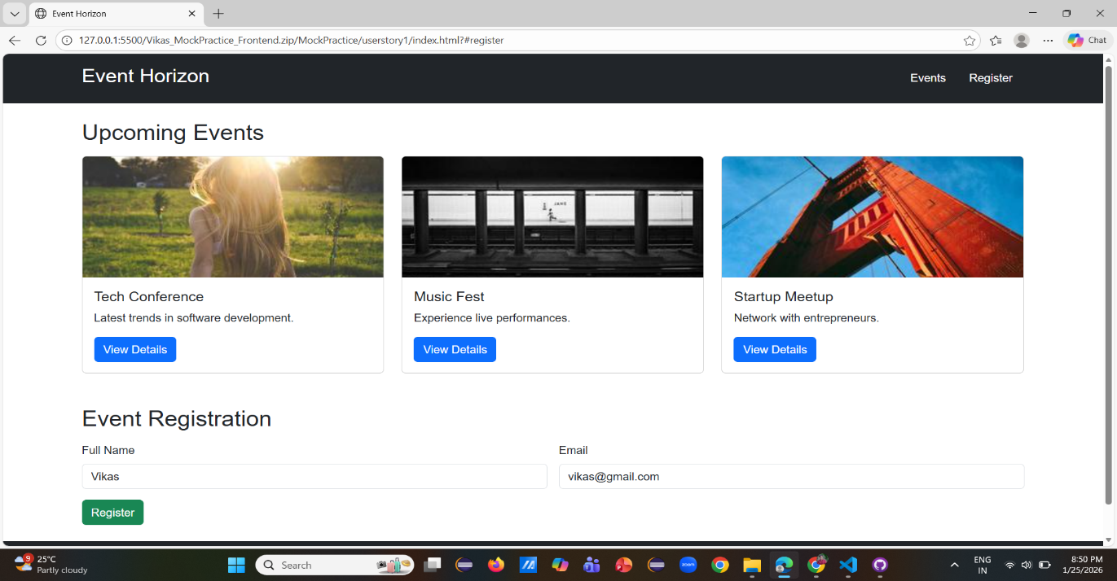

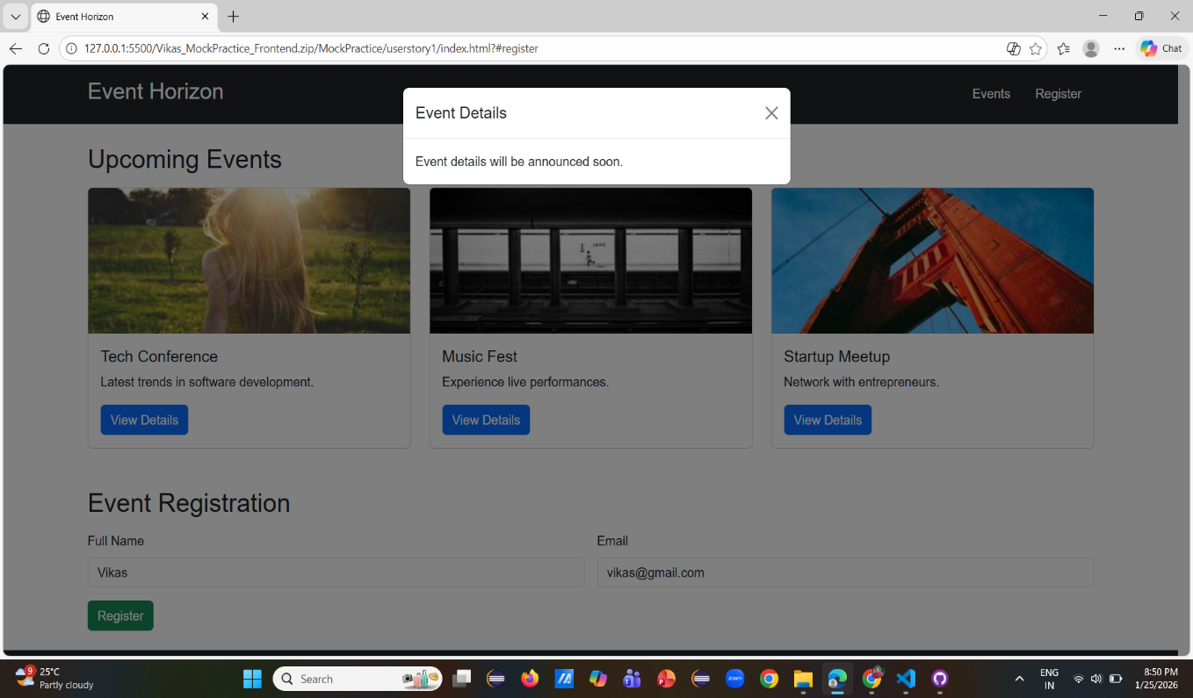
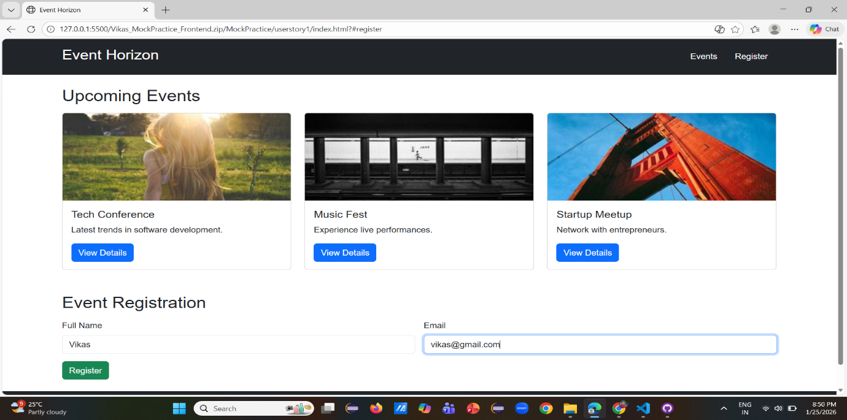

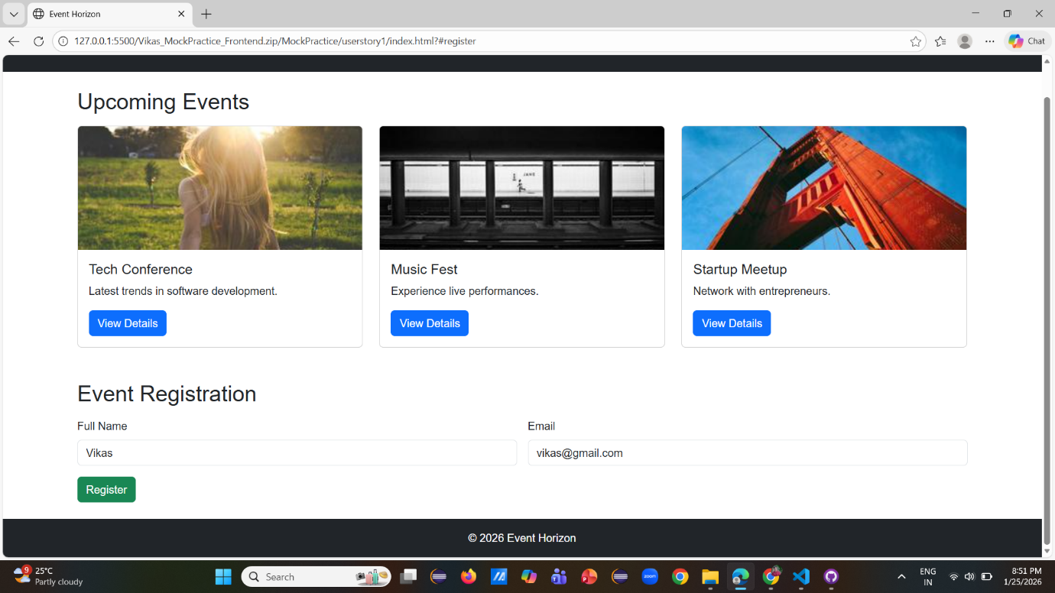

Approach Used
The homepage was designed using semantic HTML5 elements such as header, navigation, main content sections, and footer to ensure clear structure and accessibility. Bootstrap 5 was used for responsive layout management, grid alignment, and reusable UI components like cards, modals, and buttons. Event details were displayed using Bootstrap cards to maintain visual consistency. A registration form was implemented with built-in HTML validation to ensure mandatory fields and valid email input. Custom CSS was applied minimally to enhance readability and maintain a clean, professional appearance while preserving responsiveness across devices.
2) UserStory 2
Event Dashboard (JavaScript + ES6)
Scenario
Develop an interactive dashboard that displays a list of events, allows filtering by category or date, and supports live updates using JavaScript and ES6. Simulate API responses using Fetch API with a mock JSON file.
Code Snippets
events.json
[
{ "name": "Tech Conference", "category": "Technology", "date": "2026-02-10" },
{ "name": "Music Fest", "category": "Entertainment", "date": "2026-03-05" },
{ "name": "Startup Meetup", "category": "Business", "date": "2026-01-28" }
]

script.js
const eventContainer = document.getElementById("events");
const categorySelect = document.getElementById("category");

const loadEvents = async () => {
try {
const response = await fetch("events.json");
const data = await response.json();
renderEvents(data);
} catch (error) {
console.error("Failed to load events");
}
};

const renderEvents = (events) => {
eventContainer.innerHTML = "";

events.forEach(({ name, category, date }) => {
const card = document.createElement("div");
card.className = "card m-2 p-3";

card.innerHTML = `
<h5>${name}</h5>
<p>${category}</p>
<small>${date}</small>
`;

eventContainer.appendChild(card);
});
};

categorySelect.addEventListener("change", async (e) => {
const response = await fetch("events.json");
const data = await response.json();

const filtered =
e.target.value === "All"
? data
: data.filter(event => event.category === e.target.value);

renderEvents(filtered);
});

loadEvents();

index.html
<!DOCTYPE html>
<html>
<head>
<title>Event Dashboard</title>
</head>
<body>
<h2>Event Dashboard</h2>

<select id="category">
<option>All</option>
<option>Technology</option>
<option>Entertainment</option>
<option>Business</option>
</select>

<div id="events"></div>

<script src="script.js"></script>
</body>
</html>

Output Screenshots:
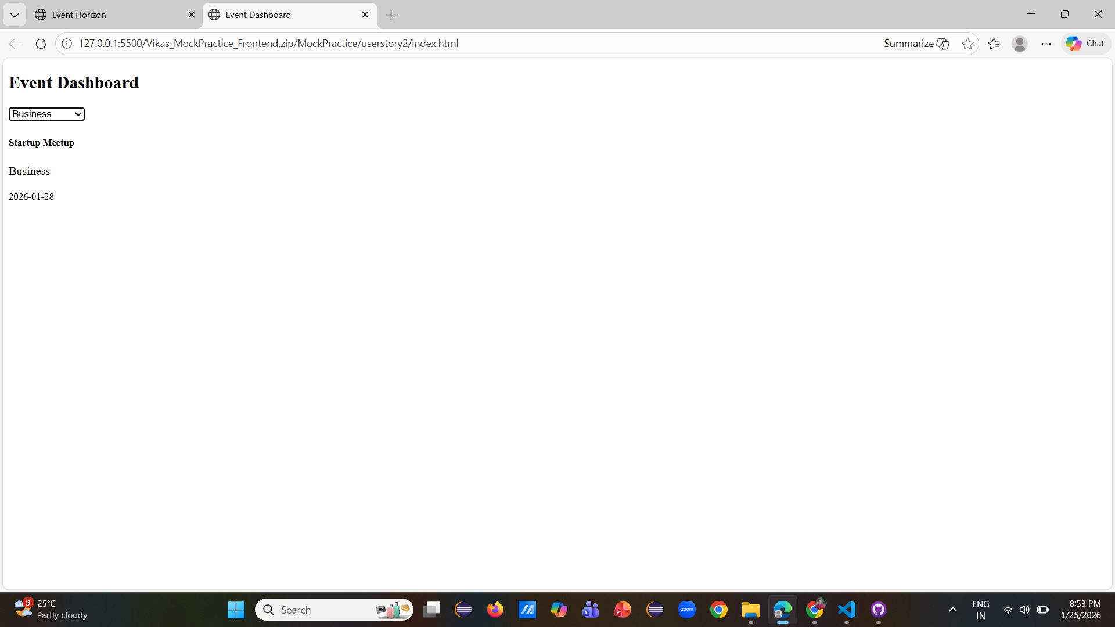

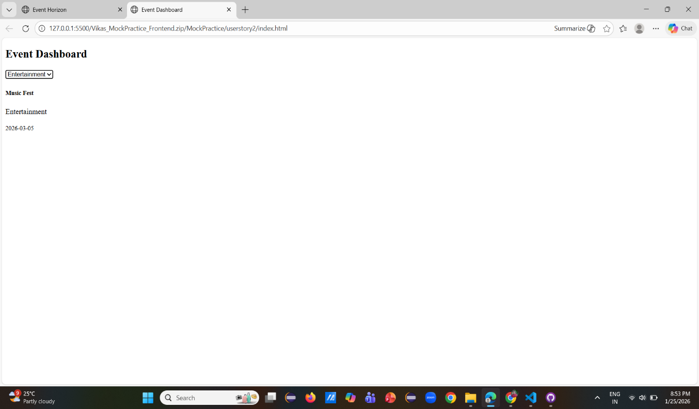
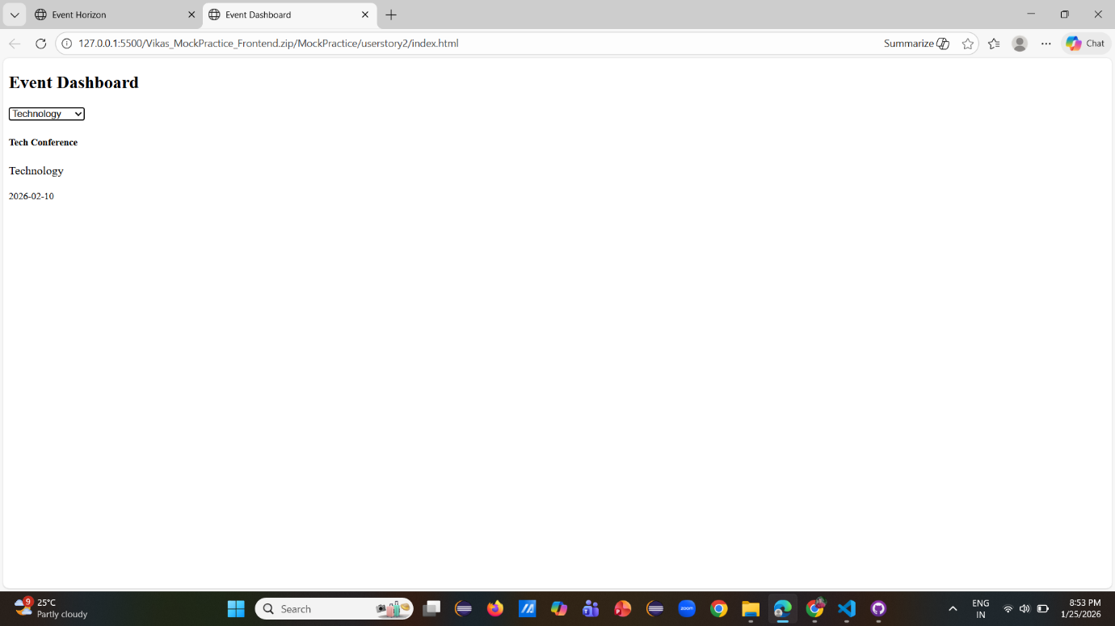
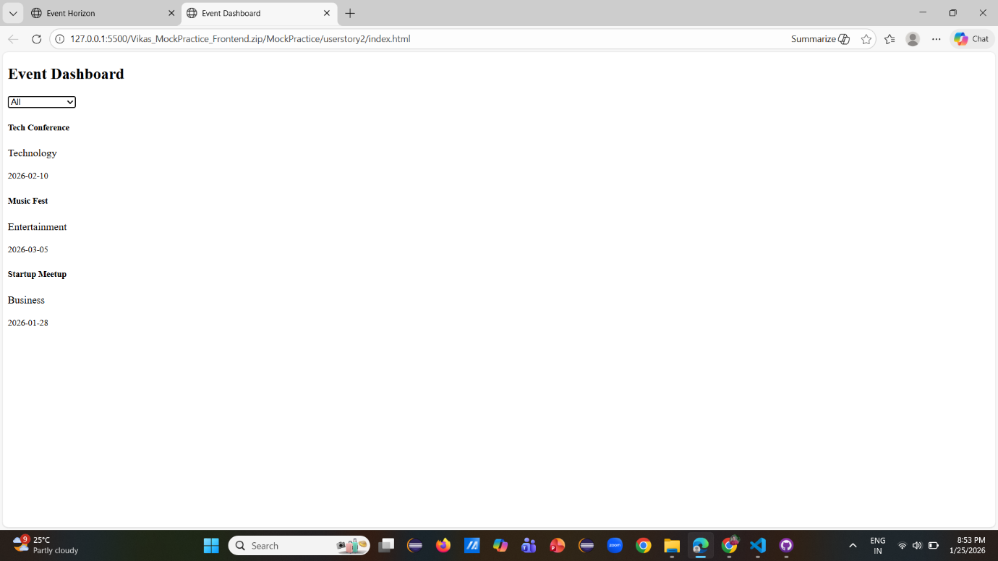
Approach Used
An interactive dashboard was developed using modern JavaScript (ES6) features such as const, arrow functions, destructuring, and template literals. Event data was stored in a mock JSON file to simulate backend API responses. The Fetch API with async/await was used to retrieve data asynchronously with proper error handling. Events were dynamically rendered in the DOM using JavaScript, and filtering functionality was implemented based on user selection. The logic was modular and readable to allow easy updates and maintainability.

3) UserStory 3
Event Dashboard (JavaScript + ES6)
Scenario
Create a TypeScript-based module that handles customer registration and management for the event platform. Demonstrate the use of interfaces, classes, decorators, enums, and tuples. Ensure the module compiles cleanly to JavaScript.
Code Snippets
CustomerModule.ts

enum CustomerType {
Regular,
Premium
}

// Tuple for contact details
type ContactInfo = [email: string, phone: string];

// Decorator with safe constructor typing
function Logger(constructor: { new (...args: any[]): {} }) {
console.log(`Class Loaded`);
}

// Interface defining customer structure
interface ICustomer {
id: number;
name: string;
type: CustomerType;
contact: ContactInfo;
}

// Customer class implementing interface
@Logger
class Customer implements ICustomer {
constructor(
public id: number,
public name: string,
public type: CustomerType,
public contact: ContactInfo
) {}
}

// Manager class handling customers
class CustomerManager {
private customers: Customer[] = [];

addCustomer(customer: Customer): void {
this.customers.push(customer);
}

// Explicit iterable return type
*getCustomers(): IterableIterator<Customer> {
for (const customer of this.customers) {
yield customer;
}
}
}

// Execution logic
const manager = new CustomerManager();

manager.addCustomer(
new Customer(1, "Vikas", CustomerType.Regular, ["vikas@mail.com", "9999999999"])
);

manager.addCustomer(
new Customer(2, "Vihaan", CustomerType.Premium, ["Vihaan@mail.com", "8888888888"])
);
manager.addCustomer(
new Customer(3, "Viyaas", CustomerType.Premium, ["Viyaas@mail.com", "7777777777"])
);
manager.addCustomer(
new Customer(4, "Vridul", CustomerType.Premium, ["Vridul.com", "666666666"])
);
manager.addCustomer(
new Customer(5, "Vikram", CustomerType.Premium, ["Vikram.com", "5555555555"])
);

// Iterator usage
for (const cust of manager.getCustomers()) {
console.log(cust);
}

CustomerModule.js
"use strict";
// enum CustomerType {
// Regular,
// Premium
// }
var __esDecorate = (this && this.__esDecorate) || function (ctor, descriptorIn, decorators, contextIn, initializers, extraInitializers) {
function accept(f) { if (f !== void 0 && typeof f !== "function") throw new TypeError("Function expected"); return f; }
var kind = contextIn.kind, key = kind === "getter" ? "get" : kind === "setter" ? "set" : "value";
var target = !descriptorIn && ctor ? contextIn["static"] ? ctor : ctor.prototype : null;
var descriptor = descriptorIn || (target ? Object.getOwnPropertyDescriptor(target, contextIn.name) : {});
var _, done = false;
for (var i = decorators.length - 1; i >= 0; i--) {
var context = {};
for (var p in contextIn) context[p] = p === "access" ? {} : contextIn[p];
for (var p in contextIn.access) context.access[p] = contextIn.access[p];
context.addInitializer = function (f) { if (done) throw new TypeError("Cannot add initializers after decoration has completed"); extraInitializers.push(accept(f || null)); };
var result = (0, decorators[i])(kind === "accessor" ? { get: descriptor.get, set: descriptor.set } : descriptor[key], context);
if (kind === "accessor") {
if (result === void 0) continue;
if (result === null || typeof result !== "object") throw new TypeError("Object expected");
if (_ = accept(result.get)) descriptor.get = _;
if (_ = accept(result.set)) descriptor.set = _;
if (_ = accept(result.init)) initializers.unshift(_);
}
else if (_ = accept(result)) {
if (kind === "field") initializers.unshift(_);
else descriptor[key] = _;
}
}
if (target) Object.defineProperty(target, contextIn.name, descriptor);
done = true;
};
var __runInitializers = (this && this.__runInitializers) || function (thisArg, initializers, value) {
var useValue = arguments.length > 2;
for (var i = 0; i < initializers.length; i++) {
value = useValue ? initializers[i].call(thisArg, value) : initializers[i].call(thisArg);
}
return useValue ? value : void 0;
};
var __setFunctionName = (this && this.__setFunctionName) || function (f, name, prefix) {
if (typeof name === "symbol") name = name.description ? "[".concat(name.description, "]") : "";
return Object.defineProperty(f, "name", { configurable: true, value: prefix ? "".concat(prefix, " ", name) : name });
};
// type ContactInfo = [string, string];
// function Logger(target: Function) {
// console.log(`Class Loaded: ${target.name}`);
// }
// interface ICustomer {
// id: number;
// name: string;
// type: CustomerType;
// contact: ContactInfo;
// }
// @Logger
// class Customer implements ICustomer {
// constructor(
// public id: number,
// public name: string,
// public type: CustomerType,
// public contact: ContactInfo
// ) {}
// }
// class CustomerManager {
// private customers: Customer[] = [];
// addCustomer(customer: Customer): void {
// this.customers.push(customer);
// }
// *getCustomers() {
// for (const customer of this.customers) {
// yield customer;
// }
// }
// }
// // Execution
// const manager = new CustomerManager();
// manager.addCustomer(new Customer(1, "Rahul", CustomerType.Regular, ["rahul@mail.com", "9999999999"]));
// manager.addCustomer(new Customer(2, "Anita", CustomerType.Premium, ["anita@mail.com", "8888888888"]));
// for (const cust of manager.getCustomers()) {
// console.log(cust);
// }
// Enum for customer classification
var CustomerType;
(function (CustomerType) {
CustomerType[CustomerType["Regular"] = 0] = "Regular";
CustomerType[CustomerType["Premium"] = 1] = "Premium";
})(CustomerType || (CustomerType = {}));
// Decorator with safe constructor typing
function Logger(constructor) {
console.log(`Class Loaded`);
}
// Customer class implementing interface
let Customer = (() => {
let _classDecorators = [Logger];
let _classDescriptor;
let _classExtraInitializers = [];
let _classThis;
var Customer = _classThis = class {
constructor(id, name, type, contact) {
this.id = id;
this.name = name;
this.type = type;
this.contact = contact;
}
};
__setFunctionName(_classThis, "Customer");
(() => {
const _metadata = typeof Symbol === "function" && Symbol.metadata ? Object.create(null) : void 0;
__esDecorate(null, _classDescriptor = { value: _classThis }, _classDecorators, { kind: "class", name: _classThis.name, metadata: _metadata }, null, _classExtraInitializers);
Customer = _classThis = _classDescriptor.value;
if (_metadata) Object.defineProperty(_classThis, Symbol.metadata, { enumerable: true, configurable: true, writable: true, value: _metadata });
__runInitializers(_classThis, _classExtraInitializers);
})();
return Customer = _classThis;
})();
// Manager class handling customers
class CustomerManager {
constructor() {
this.customers = [];
}
addCustomer(customer) {
this.customers.push(customer);
}
// Explicit iterable return type
*getCustomers() {
for (const customer of this.customers) {
yield customer;
}
}
}
// Execution logic
const manager = new CustomerManager();
manager.addCustomer(new Customer(1, "Vikas", CustomerType.Regular, ["vikas@mail.com", "9999999999"]));
manager.addCustomer(new Customer(2, "Vihaan", CustomerType.Premium, ["Vihaan@mail.com", "8888888888"]));
manager.addCustomer(new Customer(3, "Viyaas", CustomerType.Premium, ["Viyaas@mail.com", "7777777777"]));
manager.addCustomer(new Customer(4, "Vridul", CustomerType.Premium, ["Vridul.com", "666666666"]));
manager.addCustomer(new Customer(5, "Vikram", CustomerType.Premium, ["Vikram.com", "5555555555"]));
// Iterator usage
for (const cust of manager.getCustomers()) {
console.log(cust);
}

Output Screenshot
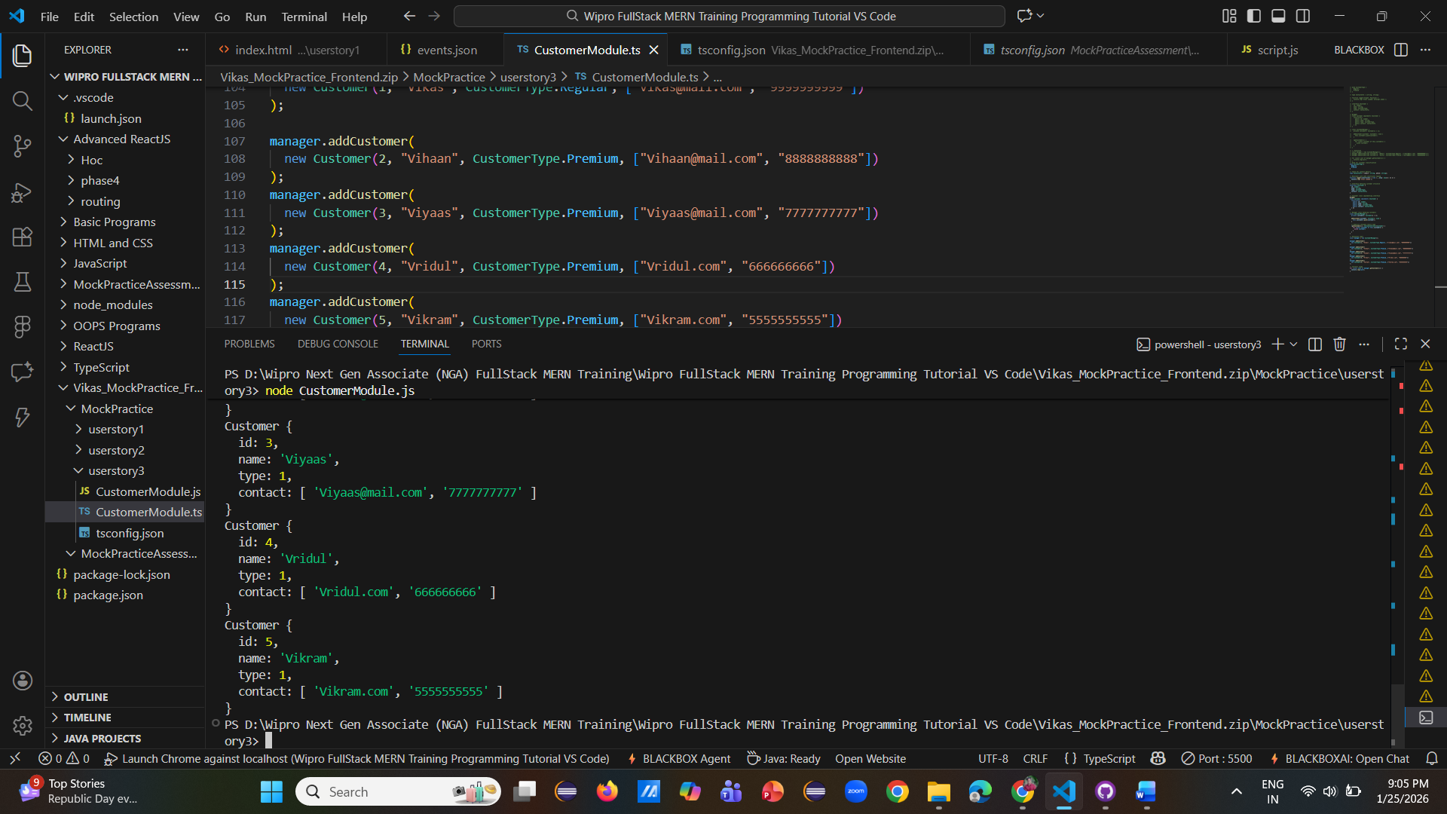
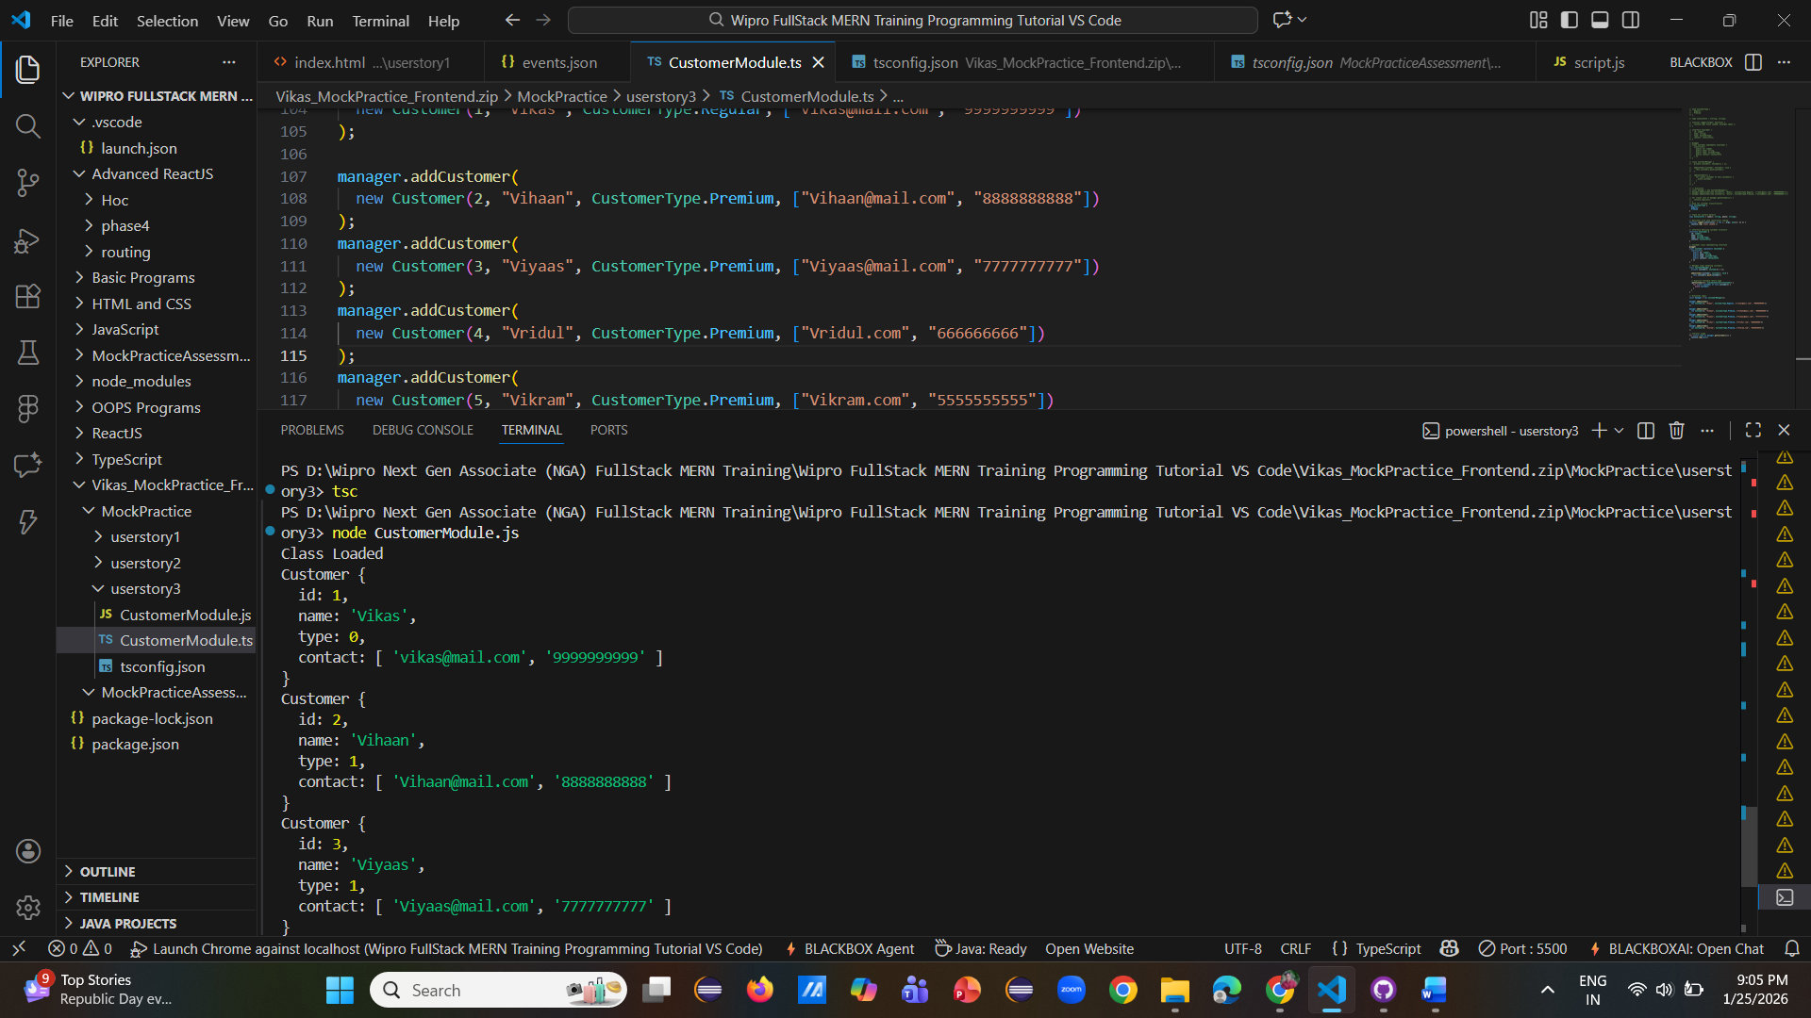
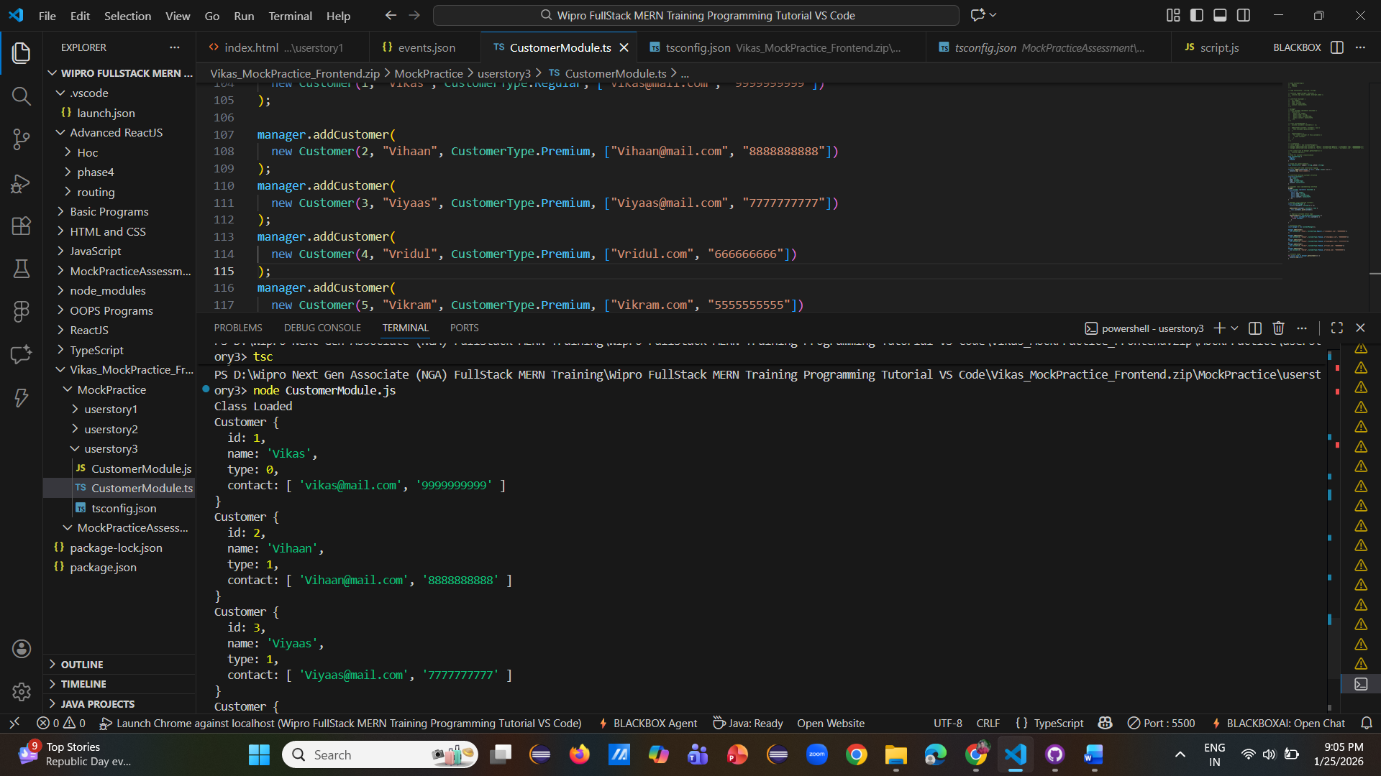
Approach Used
The customer registration module was implemented using TypeScript to ensure type safety and structured design. Interfaces were defined to enforce consistent data contracts, while classes were used to encapsulate customer logic and management functionality. Enums and tuples were applied to represent customer types and contact details accurately. A custom decorator was implemented to log class initialization, demonstrating advanced TypeScript concepts. Iterators were used to traverse customer records efficiently. The code was compiled successfully using the TypeScript compiler, producing clean and executable JavaScript output.

